There are several formulas from geometry that allow us to calculate areas of certain plane regions. We will develop some methods that use calculus to find areas of plane regions. These methods enable us to go beyond the scope of the geometric formulas and even find areas of regions that are bounded by curves instead of by straight lines.

Review of Geometric Methods

Find the area of the shaded region below.

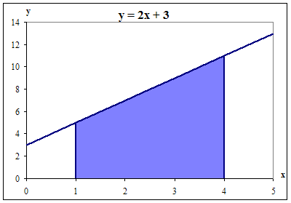

This shaded area can be described as the area bounded by the function  between   
*x* = 1 and *x* = 4.

1. What two basic geometric shapes can be used to divide the above region?
2. Find the area of each of the two geometric shapes from part (a).
3. Find the total area of the shaded region.
4. Do you remember any other methods of finding the area of a shape like above?

**Riemann Sums**

Let’s reconsider the previous problem, but using a series of rectangles to approximate the area.

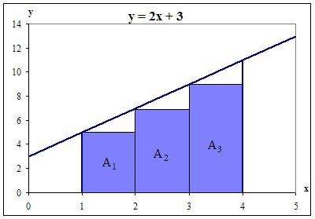

Note: Each rectangle has a height determined by the value of *f* (*xL*), where *xL* is the *x* coordinate at the **L**eft corner of the base of that rectangle, all the rectangles have the same width, ∆*x*, and the area of each rectangle, *AL*, can be computed using the geometric formula: *AL* = length × width = *f* (*xL*) × ∆*x*.

Approximate the area bounded by the function  and the *x*-axis between *x* = 1 and *x* = 4 by finding the total area of the shaded rectangles above.

Let’s again reconsider the above problem, but now using 6 rectangles to approximate the area.

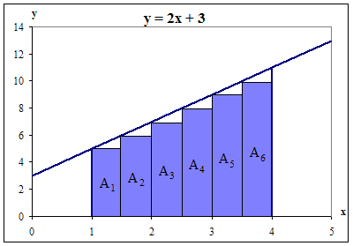

Compute the total area of the 6 shaded rectangles. How does this value compare with your approximation with 3 rectangles and the actual value?

Summations of this type,, are called Riemann Sums.

**Using Your Calculator to Compute the Area Under a Curve**

1. A method that can be used on the TI-84 or TI 89 graphing calculator uses two programs. Locate the two programs **sum(seq**(expression, variable, low, high, step)) under the List Menu/OPS and MATH on the TI-84 and the Math Menu/List on the TI-89. Type the function into y1, then use the two programs as follows:
2. Expression = y1(*x*)* (**b** – **a**)/**n**
3. Variable = *x*
4. Low = **a**
5. High = **b** – (**b** – **a**)/**n**
6. Step = (**b** – **a**)/**n**

Alternatives:

1. Right Endpoint – Low = **a** + (**b** – **a**)/**n** and High = **b**
2. Midpoint – Low = **a** + (**b** – **a**)/(2**n)** and High = **b** − (**b** – **a**)/(2**n)**
3. Another method that only the TI-89 graphing calculator is able to do uses the **Σ**(expression, variable, lower limit, upper limit) program under the Calc Menu. Type the function into y1, then use the program as follows:
4. Expression = y1(**a** + (*i* – 1)*(**b** – **a**)/**n**)*(**b** – **a**)/**n**
5. Variable = *i*
6. Lower limit = 1
7. Upper limit = **n**

Alternatives:

1. Right Endpoint – Expression = y1(**a** + *i*\*(**b** – **a**)/**n**)*( **b** – **a**)/**n**
2. Midpoint – Expression = y1(**a** + (2*i* – 1)*(**b** – **a**)/(2**n)**)*( **b** – **a**)/**n**

**Spreadsheet Template: Computing the Area Under a Curve**

The figure below illustrates the *initial setup* for the 6 rectangles on the previous page.

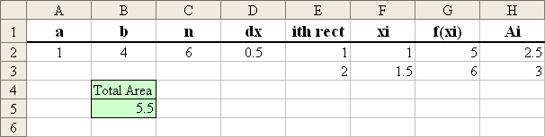

For the above template:

1. The **a** and **b** are the left and right endpoints, respectively, of the total area.
2. The **n** is the number of rectangles used.
3. The **dx**, or ∆*x*, is the width of each rectangle, and is computed by (**b** – **a**)/**n**.
4. The **ith rect** represents which rectangle you are computing.
5. The **xi** represents the *x* coordinate for that rectangle.
6. The **f(xi)** is the function evaluated at the corresponding **xi**.
7. The **Ai** is the area for that rectangle.

Formulas in the template:

|  |  |  |  |  |  |  |  |  |
| --- | --- | --- | --- | --- | --- | --- | --- | --- |
|  | A | B | C | D | E | F | G | H |
| 1 | **a** | **b** | **n** | **dx** | **ith rect** | **xi** | **f(xi)** | **Ai** |
| 2 | 1 | 4 | 6 | =(B2-A2)/C2 | 1 | =A2 | *f* (F2) | =G2*$D$2 |
| 3 |  |  |  |  | 2 | =F2+$D$2 | *f* (F3) | =G3*$D$2 |
| 4 |  | Total Area |  |  | … | … | … | … |
| 5 |  | =SUM(H:H) |  |  | … | … | … | … |

Using the template:

1. Enter the values for **a**, **b** and **n**.
2. Enter the formulas for **dx**, **xi** and **Ai**.
3. Enter the given function *f* (*x*) into the **f(xi)** column, using the **xi** values for *x*.
4. Select the four cells in row 3 (E3:H3) and drag down until the value of **ith rect** is equal to the **n**.
5. Enter the formula for the **Total Area**.

Alternatives:

1. If using the Right endpoint for the rectangle height, then the formula in F2 will be “=A2 + D2”.
2. If using the Midpoint for the rectangle height, then F2 will be “=A2 + D2/2”.

**Use your calculator or an Excel spreadsheet to approximate the area bounded by the function  between *x* = 1 and *x* = 4.**

|  |  |
| --- | --- |
| Number of Rectangles, *n* | Approximate Area under *f* (*x*) |
| 25 |  |
| 50 |  |
| 100 |  |
| 500 |  |

**Summary**

We can define the area bounded by any function *f* (*x*) and the *x*-axis between *x* = *a* and *x* = *b* by the Riemann Sum

|  |
| --- |
|  |

where ∆*x* is the width of each rectangle and *xi* is an *x* coordinate in each rectangle.

1. What is it about this definition that allows us to claim that we have the exact area between the *x*-axis and the function's graph, even though the boundary at the top of this region is a curve?
2. Does it matter whether we use a left-side, right-side, or mid-point version of the Riemann sum in the calculation of the exact area? Why or why not?

Use your calculator or an Excel spreadsheet and right endpoints to determine the area bounded by from *x* = 0 to *x* = 3.

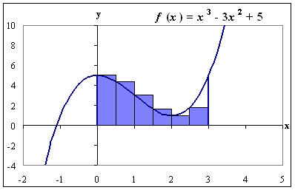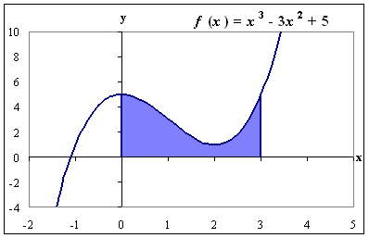

1. Complete the following table.

|  |  |
| --- | --- |
| Number of Rectangles, *n* | Approximate Area under *f* (*x*) |
| 6 |  |
| 25 |  |
| 50 |  |
| 100 |  |
| 500 |  |

1. What is happening to the area calculations as the number of rectangles increases?
2. Area =  = ______________________

Use your calculator or an Excel spreadsheet to determine the area bounded by the x-axis and the graph of f(x) =from x = 0.6 to x = 7.8. This time use left endpoints, instead of right endpoints.

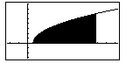

1. Complete the following table.

|  |  |
| --- | --- |
| Number of Rectangles, *n* | Approximate Area under *f* (*x*) |
| 6 |  |
| 25 |  |
| 50 |  |
| 100 |  |
| 500 |  |

1. What is happening to the area calculations as the number of rectangles increases?
2. Area =  = ______________________